2011 Board Meeting Dates

Below is the meeting schedule for 2011:

11/21/11 – Budget and Annual Meeting

All meetings take place at the Indian Head Park village hall at 201 Acacia Drive and begin promptly at 7PM. Owners are encouraged to attend these meetings whenever possible. Time is allotted to address residents’ concerns at the end of each meeting.

If you are unable to attend the meeting, please send your proxy to Elite Management by November 18th. The proxy can be faxed to Elite Management at (708) 352-2871 or mailed to PO Box 628, Western Springs, IL 60558.


2012 Budget

The Board and management were pleased to present the 2012 budget with no assessment increase. We hope the letter and supporting documentation was helpful in clarifying the association’s future planning and financial position. Feel free to contact us with any questions or concerns. This budget is scheduled to be passed at the upcoming November meeting.



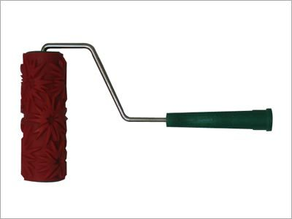
Chestnut “Happenings”

The re-staining of the decks was completed on the north five buildings. I heard a few positive comments on the solid color stain. During the next cycle, the south five buildings will also be done in a matching solid colored stain. Wood replacement was completed as needed and continues to be completed on an annual basis. As a note, the buildings are typically painted every five years. Deck staining cannot wait this long so this is normally done every other year or once every three years depending on the existing condition.


The Association recently repaired around all the sewers and crack filled the asphalt in the auto courtyards. Items such as these are reviewed annually and repaired on an as needed basis.

Landscape enhancement work was completed by Ground Pros in September and the Association was pleased with the results. We will continue to work on improving the grounds as the budget permits.

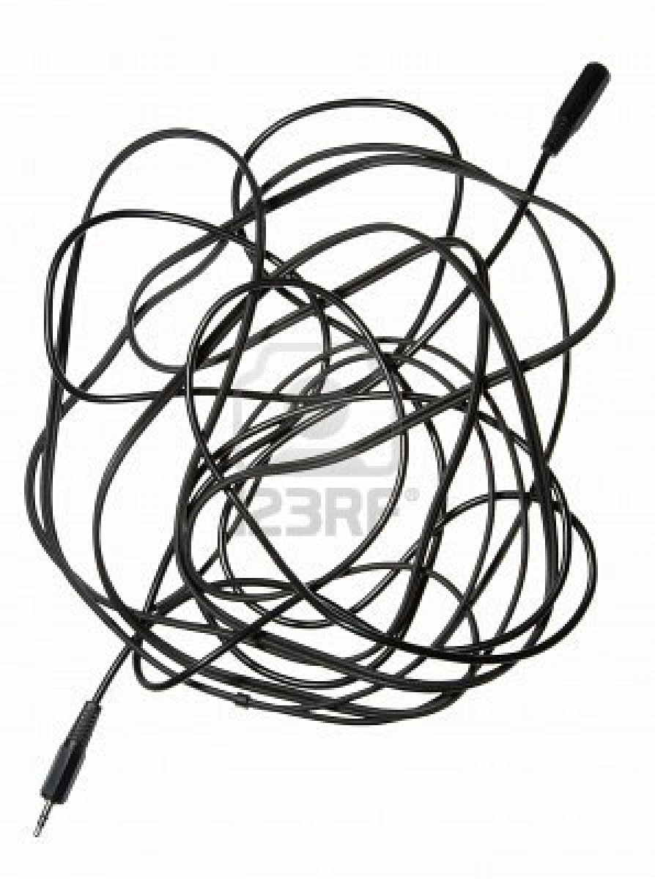
Speaking of improving the grounds, if you have exposed cables around your unit, please call the appropriate utility and have these buried. The Association cannot handle this because we do not have an account with AT&T, Comcast, etc. Additionally, some units have exposed wiring on the outside siding that does not look good. This is normally due to a poor cable/satellite installation. We plan to walk the grounds in the spring and send letters to these owners. These wiring issues must be addressed promptly.

Another Note: Recently, we had a report of a raccoon or possum that got onto the building and pulled down an area of the soffit. Please do not leave out any type of food (including bird feeders) as this brings these types of critters around. If you see any damaged areas of the building please notify management as soon as possible. Thank you in advance for your cooperation.

Fun Thanksgiving Facts
- Sarah Josepha Hale, an American magazine editor, persuaded Abraham Lincoln to declare Thanksgiving a national holiday. She is also the author of the popular nursery rhyme "Mary Had a Little Lamb"
- In 1939, Franklin Roosevelt changed Thanksgiving to a week earlier than usual so the Christmas shopping season would last longer. There was a tremendous outpouring of public disapproval over the next two years so, in 1941 he admitted his mistake and officially declared the fourth Thursday in November a national holiday for Thanksgiving.
- In the US, about 280 million turkeys are sold for the Thanksgiving celebrations.

- Benjamin Franklin believed that the national bird should have been recognized as a wild turkey and not the bald eagle.
- The first time the Detroit Lions played football on Thanksgiving Day was in 1934, when they hosted the Chicago Bears at the University of Detroit stadium, in front of 26,000 fans. The NBC radio network broadcast the game on 94 stations across the country--the first national Thanksgiving football broadcast. Since that time, the Lions have played a game every Thanksgiving (except between 1939 and 1944); in 1956, fans watched the game on television for the first time.

Exterior Modification Forms
Please remember that the submission of an architectural change form with an attached drawing is required prior to any changes affecting the exterior of your unit and common elements. Common requests include: replacing windows and doors, satellite dishes, and landscaping additions. The only exceptions are flowers in the mulch beds; EVERYTHING else needs prior Board approval.
If you are contemplating making changes to your unit that impact the exterior, please save yourself the expense and hassle by clearing any major changes with management first!

Newsletters

We sincerely hope that you have enjoyed this edition of the newsletter!

The Association’s quarterly newsletter is designed to update you of community news and other important events. If you have something you would like included in the next newsletter, please send the information to bkovel@elitemgt.net.

Important Contact Information

Management Company Information:

Elite Management Associates, Inc.
PO Box 628
Western Springs, IL 60558
Office: (708) 352-2870
Fax: (708) 352-2871
www.elitemgt.net

Board of Directors Information
www.chestnutonthegreen1.com

President – Carol Rettker (2011)
Vice President – Rick Dahl (2011)
Secretary – Jon Buralli (2012)
Treasurer – Ann Dee (2012)
Director – Kim Blaze (2012)

Indian Head Park Information
www.indianheadpark-il.gov
201 Acacia Drive
Indian Head Park, IL 60525
Police Emergency 911
Police Non-Emergency (708) 246-4534
Police Fax (708) 246-9357

