2012 Board Meeting Dates

2/27/12 – General Meeting
5/7/12 – General Meeting
8/6/12 – General Meeting
11/5/12 – Annual and Budget Meeting

All meetings take place at the Indian Head Park village hall at 201 Acacia Drive and begin promptly at 7PM. Owners are encouraged to attend these meetings whenever possible. Time is allotted to address residents’ concerns at the end of each meeting.


2011 Financials

The Association’s financial performance in 2011 is included in this newsletter. We have attached a balance sheet as of December 31, 2011 and a profit and loss statement through December 31, 2011. If there are any questions, please email them to bkovel@elitemgt.net. We find it very important that the owners understand the financial position of the Association.

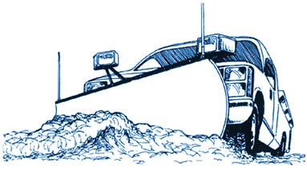
Snow and Ice Clearing Operations


I am confident everyone is enjoying the mild temperatures and weather this year. However, snow can come as late as April in this area. Therefore, please keep in mind that our snow clearing contract comes into effect only when snow accumulation is 2” or greater. Owners are advised to keep a shovel on hand and “safety salt” (a blend of salts – containing lesser amounts of sodium chloride) or calcium chloride to maintain walks for those times when snow accumulation is less than 2”, and for treatment of moderate ice. Please use snow melts wisely! Avoid excessive use of ice and snow melts, which may cause damage to concrete and kills vegetation.


Holiday Decorations

Please remember that decorations should be removed within 30 days after the holiday. Thank you in advance for your cooperation!

Garbage Day


As you all know, those windy garbage days make it difficult to keep the community free of litter. Additionally, over the winter months, our landscape contract does not cover off season clean-ups. Therefore, special visits for trash clean-up cost the Association money. Please keep a durable container with a tight lid to retain trash. Also, try to write your house number on your container and lid. Lastly, if you recycle paper or other light weight items, please make sure they are weighted down and all cardboard items are flattened out. Thanks for helping keep the community clean and keeping costs down. One final note, please remember not to leave your trash cans out. Trash cans left out make the property look unkempt.

2012 Coupon Books

Coupon Booklets have been distributed to unit owners. Remember to pass these on to new owners in the event of a transfer of ownership. If you are signed up for automatic payment, you will not be receiving coupon books for 2012.


Fun Chicago Winter Facts
- Chicago’s snow season: July and August are the city’s only totally snow-free months. Traces of snow have fallen as late as June 2, 1910, and as early as September 25, 1928 and 1942. Because June is considered to be a summer month, it is true that snow has occurred here in every season.
- Chicago’s snow extremes: Greatest snowstorm, 23.0 inches January 26-27, 1967; snowiest and least-snowy winters, 89.7 inches 1978/79 and 9.8 inches 1920/21; greatest snow depth on ground, 29 inches January 14, 1979.
- Chicago temperature surprise: Based on Midway and O’Hare data, daily high temperatures in the 60s occur more often in the city during December than during July.

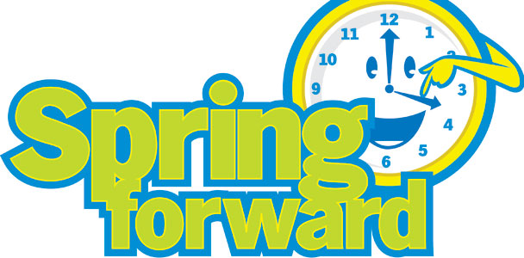
For your March calendars … don’t forget to “spring ahead” with your clocks 1 hour before you go to bed on Saturday, March 10th. Daylight Saving Time starts on the 11th. Also, 2012 is a leap year – watch for February 29th to appear on your calendars!

Exterior Modification Forms
Please remember that the submission of an architectural change form with an attached drawing is required prior to any changes affecting the exterior of your unit and common elements. Common requests include: replacing windows and doors, satellite dishes, and landscaping additions. The only exceptions are flowers in the mulch beds; EVERYTHING else needs prior Board approval.
If you are contemplating making changes to your unit that impact the exterior, please save yourself the expense and hassle by clearing any major changes with management first!

Newsletters

We sincerely hope that you have enjoyed this edition of the newsletter!

The Association’s quarterly newsletter is designed to update you of community news and other important events. If you have something you would like included in the next newsletter, please send the information to bkovel@elitemgt.net.

Important Contact Information

Management Company Information:

Elite Management Associates, Inc.
PO Box 628
Western Springs, IL 60558
Office: (708) 352-2870
Fax: (708) 352-2871
www.elitemgt.net

Board of Directors Information
www.chestnutonthegreen1.com

President – Carol Rettker (2013)
Vice President – Rick Dahl (2013)
Secretary – Jon Buralli (2012)
Treasurer – Ann Dee (2012)
Director – Kim Blaze (2012)

Indian Head Park Information
www.indianheadpark-il.gov
201 Acacia Drive
Indian Head Park, IL 60525
Police Emergency 911
Police Non-Emergency (708) 246-4534
Police Fax (708) 246-9357

