2021 Board Meeting Dates

5/3/21 – General Meeting
8/9/21 – General Meeting
11/8/21 – Annual and Budget Meeting

***NOTICE, This Board Meeting will be held via Conference Call, Information on how to join can be found below***

Conference Call Information
Dedicated Dial-in: 1-312-667-4792
Conference Code: 973176

We ask all owners who attend the conference call to hold all questions until the business portion of the meeting is complete. Thank you in advance for your cooperation during this time.

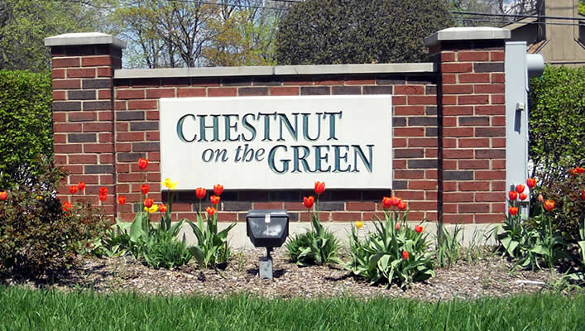
Chestnut on the Green News and Updates

Grounds

- Paramount Landscaping completed the spring clean ups on April 8th. Soon pre-emergent crab grass control will be applied along with a spring fertilizer.

- Midwest Ecology completed the controlled burn on the west side of the property this month. This burn was completed to prevent the invasive plants in that area from growing up over the berm and getting into the pond.

- Basic Irrigation completed the aerator installation for the season.
- The Board approved the installation of mulch again this season. We will schedule the install for early summer.

- The landscape committee will continue to do small improvements around the property this year. If you have the time and would like to help out please contact Laura at Elite Management and she will put you in touch with a committee person.

- The Association installed a Phase I parking only sign at the guest spots on the Northeast side of Flagg Creek, where we were having trouble with Phase II owners parking for long periods of time.

Buildings:
- Balconies are the Associations main focus this year. The board is looking at replacing all railing components with a no maintenance material. They are currently reviewing bids and planning the funding for the project. A special assessment may be needed to help cover the costs of these replacements.

- Gutter cleaning will be scheduled in the late spring or early summer. This work will take place once the cotton wood trees on the east side have stopped shedding.

- D&I Electronics will change their dispatch procedure as a result of many owners moving away from landlines. Moving forward they will now call the first key holder on the account (this number should be the owner’s cell phone). If that number is not answered and no password is received the fire department will be dispatched.

Master Association Happenings

- The Master Association contracted with Collins Engineers to complete the tri-annual bridge inspection. This work will take place this spring.

Chestnut Reminders

- Do not speed while driving on Flagg Creek. There are a lot of kids in the area and we would like to keep our children safe.

- Garbage cans and recycling bins are to be placed at the curb no earlier than 6:00 PM the night prior to garbage pick-up, and must be brought in no later than 6:00 PM the day of pick-up. If an owner requires large items such as furniture to be removed they must arrange a pickup with the scavenger company; please note the Association does not have an account with the scavenger service and is not able to schedule these types of pickups.

- Dog owners must clean up after their pets immediately. It is expected that you walk your pets down by the designated walking area and take use of the pet waste station provided by the Master Association. Owners reported not cleaning up after their pets will be fined.

- No empty planters or planters containing dead plants may be stored outside at any time. Only planters with live plants may be displayed.

- Please remember that the submission of an architectural change form with an attached drawing is required prior to any changes affecting the exterior of your unit and common elements. Common requests include: replacing windows and doors, satellite dishes, and landscaping additions.
Newsletters

The Association’s quarterly newsletter is designed to update you of community news and other important events. If you have interesting news to share about upcoming events, personal milestones or issues of community interest please email the property manager and we will be sure to include it in our next Newsletter!

Important Contact Information
Elite Management Associates, Inc.
PO Box 628
Western Springs, IL 60558
Office: (708) 352-2870
Fax: (708) 352-2871
www.elitemgt.net
Laura Sneed
Property Manager
lsneed@elitemgt.net

Follow us on twitter @elitemgtnet
Board of Directors Information
www.chestnutonthegreen1.com
President – Jon Buralli
Vice President – Kim Blaze
Secretary – Carol Rettker
Treasurer – Joan Rucker
Director – James Ryva
Indian Head Park Information
www.indianheadpark-il.gov
201 Acacia Drive
Indian Head Park, IL 60525
Police Emergency 911
Police Non-Emergency (708) 246-4534
Police Fax (708) 246-9357

