2019 Board Meeting Dates

4/30/19 – General Meeting
8/13/19 – General Meeting
11/26/19 – Annual and Budget Meeting

All meetings take place on Tuesdays at the Indian Head Park village hall at 201 Acacia Drive and begin promptly at 7PM. Owners are encouraged to attend these meetings whenever possible. Time is allotted to address residents’ concerns at the end of each meeting.

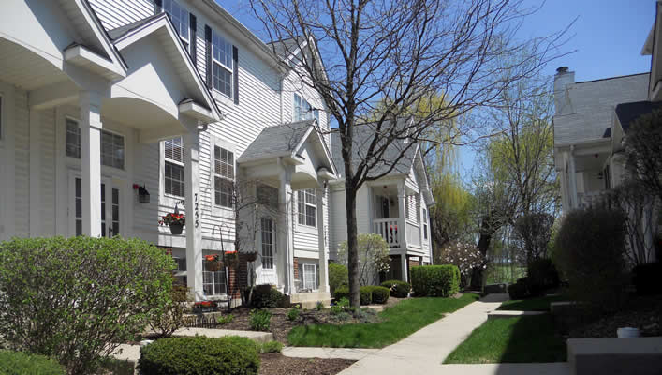
Buildings

Power washing: As explained in previous communications the board will be working with a professional power washing company to clean the exterior of all the buildings; this work will be billed back to all homeowners. We are currently obtaining bids; once a vendor is chosen a notification will be sent to owners with a timeline and cost for the project.

Roofing: Phase II of the Association’s roof replacement project will take place starting this June (weather permitting). See below for the 2019 and 2020 schedule:

Address | Roof Replacement
7200-7210 | 2019
7201-7209 | 2019
7212-7218 | 2019
7251-7257 | 2020
7261-7269 | 2020
7271-7279 | 2020

Grounds

- Ground Pros completed the spring clean ups the 1st week of April.

- Fountains were installed by basic irrigation in the North and South Ponds. In the past it has been reported that children are removing the rocks along the perimeter of the North pond, if you see this type of behavior please ask them to stop; the cost to replace these rocks is significant.

- Crab Grass control will be applied throughout the property later this spring.

- Concrete repairs will take place at various locations throughout the property this April.

Landscape Committee Updates

- A small stone bench and memorial plaque will be placed by the South pond in memory of resident Matthew Korwel who passed away in August 2017. Matt was a wonderful neighbor and friend who was instrumental in cleaning up the South pond. He loved gardening and took pride in our property at Chestnut on the Green. We miss you Matt!

- The committee will be doing turf repairs this spring. These areas will be clearly marked with blue flags. If you see these flags by your unit we ask that you please take the time to water these areas daily.


Spring – Summer Travel

This time of year many people go out of town; whether you are out visiting relatives, taking a small weekend getaway or going on a nice long summer vacation. Below are some ideas to deter thieves and protect your home while you're away:

- Leave drapes and shades open. If closed, it's a sign you're gone.

- Don't stop all deliveries. Have someone you trust pick up mail and newspapers every day.

- Leave a radio on. It signals to a burglar that someone's home.

- If you have a home phone turn down the volume so a prowler will be less likely to hear the ringing of an unanswered call.

- Use automatic light timers. Set them to turn lights on and off in different rooms at different times.

- Park a car in your driveway or parking space. If you plan to be gone for just a few days, park your second car in the driveway or space, or ask a neighbor to park a car there. This not only gives the impression you're home but also stops burglars from backing up a van and loading your possessions.

Newsletters

The Association’s quarterly newsletter is designed to update you of community news and other important events. If you have interesting news to share about upcoming events, personal milestones or issues of community interest please email the property manager and we will be sure to include it in our next Newsletter!

Upcoming Observances

Sunday April 22nd – Earth Day; Earth Day is an event observed annually on April 22. It is a day held to demonstrate and promote environmental awareness and calls for the protection of our planet.

Sunday May 13th – Mother’s Day; The History of Mother's Day dates back to the 19th century, when women's peace groups in United States of America often tried to establish holidays and regular activities in favor of peace and against war. A common regular activity was the meeting of groups of mothers whose sons had fought or died in the American Civil War.

Saturday May 19th – Armed Forces Day; This day is dedicated to paying tribute to men and women who currently serve in the United States' armed forces.
Important Contact Information
Elite Management Associates, Inc.
PO Box 628
Western Springs, IL 60558
Office: (708) 352-2870
Fax: (708) 352-2871
www.elitemgt.net
Laura Sneed
Property Manager
lsneed@elitemgt.net

Follow us on twitter @elitemgtnet
Board of Directors Information
www.chestnutonthegreen1.com
President – Jon Buralli
Vice President – Kim Blaze
Secretary – Lily Anne Nueva Espana
Treasurer – Joan Rucker
Director – James Ryva
Indian Head Park Information
www.indianheadpark-il.gov
201 Acacia Drive
Indian Head Park, IL 60525
Police Emergency 911
Police Non-Emergency (708) 246-4534
Police Fax (708) 246-9357

